**Day 2 Tuesday Gaurav Gupta**

**LVM**

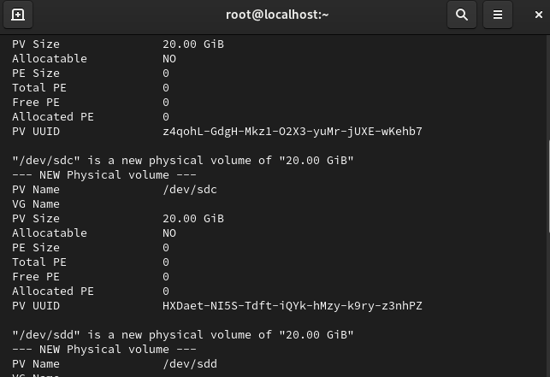

To install and configure an FTP server using **vsftpd** on CentOS 9, follow these steps:

sudo dnf update

sudo dnf install vsftpd

sudo systemctl start vsftpd

sudo systemctl enable vsftpd

sudo nano /etc/vsftpd/vsftpd.conf

write_enable=YES

pasv_enable=YES

pasv_min_port=10000

pasv_max_port=10100

sudo firewall-cmd --permanent --add-service=ftp

sudo firewall-cmd --permanent --add-port=10000-10100/tcp

sudo firewall-cmd –reload

sudo systemctl restart vsftpd

ftp your_server_ip